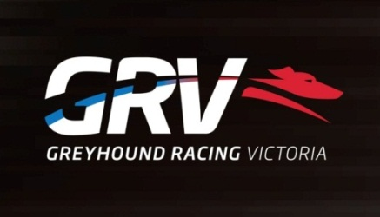
Club Manager – Traralgon Greyhound Racing Club
- Traralgon Based
- Permanent Position
- Manage Race Day Operations and Functions

The Traralgon Greyhound Racing Club conducts weekly race meetings and trial sessions providing industry participants and local community with quality racing facilities while ensuring maximum returns for the club.
The Club Manager supports the Traralgon Committee in ensuring a high level of professionalism in managing the overall strategic direction and operations of the club. Ensuring that all race meetings and trial sessions are conducted to the highest standard. The manager is required to ensure local community involvement and the acquisition of sponsors to ensure the club is seen as not only a great place to watch greyhound racing, but also a preferred venue for a function or event.
Developing strong working relationships with club staff, committee members and industry participants, the position is also responsible for managing the administrative and financial operations of the Traralgon Greyhound Racing Club in the best interest of its stakeholders and in conjunction with the Committee and the Club’s Improvement Plan.
To be considered for this role you will have:
- Demonstrated ability to seek opportunity for business improvement.
- Demonstrated ability to establish and manage budgets and business finances.
- Strong capability to direct and lead others for high performance.
- Strong negotiation, influencing and communication skills.
- Ability to drive change.
- Strong strategic and operation focus.
- Understanding of Workplace Health and Safety requirements.
- Experience with Committees including preparation of documentation and minute taking.
- Sound computer skills including competent use in Microsoft Outlook, Excel and Word.

To lodge your application for this position please respond by addressing the selection criteria and forward your application addressed to Don Haley, President, Traralgon Greyhound Racing Club to careers@grv.org.au by Friday 16th December 2016.

For further information, please contact Meredith Hill on telephone number (03) 8329 1227

GRV is an EEO employer
All offers of Employment will be subject to a satisfactory police check
All employees must have the right to work in Australia

