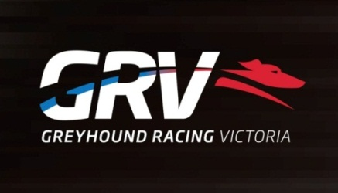
Stewards x 2 Full Time Positions

- West Melbourne
- Travel will be a requirement of the positions
- Current Victorian Driver’s Licence Mandatory
Greyhound Racing Victoria (GRV) regulates and promotes greyhound racing at the State level with animal welfare and integrity as its key priorities. GRV is committed to attracting, selecting and retaining the best calibre of people to achieve the highest level of performance and behavioural standards required for each position and are seeking passionate and professional persons to fill the roles of Stewards.
The principal purpose of these positions are to oversee the proper administration of race meetings. This includes ensuring all kennelling procedures are adhered to, directing the taking of samples for prohibited substance detection, supervising the conduct of race day officials and staff, undertaking inquiries where required and in general ensuring the smooth and fair running of a meeting in accordance to the rules.
The successful applicant will possess:
- Highly developed communication skills
- Strong conflict resolution skills
- An ability to work as part of a team and show leadership where required
- Well-developed time and self – management skills
- Organisational skills
- Good data entry/keyboard skills
- Sound literacy and numeracy skill
- A current Victorian driver’s license
To apply for this position please send your cover letter addressing the above selection criteria together with a copy of your resume to careers@grv.org.au by Close of Business 13th of October 2016
For further information, please contact Joe Ruggiero on telephone number (03) 8329 1132 or for a copy of the position description, please visit our web site – www.grv.or.au
GRV is an EEO employer
All offers of Employment will be subject to a satisfactory police check
All employees must have the right to work in Australia

