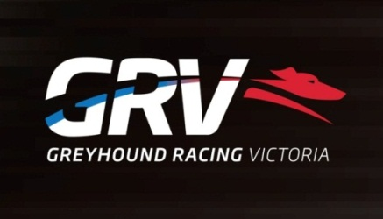
Investigations Officer x 2
- West Melbourne
- 2 positions - Full Time and 12 Month Contract
- Must be prepared to travel throughout the State at varied hours

Greyhound Racing Victoria (GRV) regulates and promotes greyhound racing at the State level with animal welfare and integrity as its key priorities. GRV is committed to attracting, selecting and retaining the best calibre of people to achieve the highest level of performance and behavioural standards required for each position and are seeking a passionate and professional manager to fill the role of Investigations Officers.
The primary purpose of the Investigations Officer role is to ensure that regulatory enforcement investigations are carried out. Conduct sound and procedurally correct investigations into all matters referred to GRV.
The successful applicant will possess:
- Vast and demonstrable investigative experience
- Experience in preparing and presenting evidence in an inquiry/court setting
- Thorough knowledge of legalities associated with investigations
- Effective interviewing skills
- Highly developed communication skills
- Highly developed report writing skills
To lodge your interest for this position please complete the internal job application form and forward your application to jruggiero@grv.org.au by Friday 7/10//2016.
For further information, please contact Joe Ruggiero on telephone number (03) 8329 1132
GRV is an EEO employer
All offers of Employment will be subject to a satisfactory police check
All employees must have the right to work in Australia

