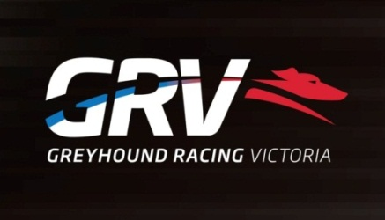
GAP Administration Assistant

- Full Time Positions
- Customer Service and Administrative function
- Seymour based
Greyhound Racing Victoria (GRV) regulates and promotes greyhound racing at the State level with animal welfare and integrity as its key priorities. GRV is committed to attracting, selecting and retaining the best calibre of people to achieve the highest level of performance and behavioural standards required for each position and are seeking passionate and professional person to fill the role of GAP Administration Assistant
Greyhound Racing Victoria (GRV) regulates and promotes greyhound racing at the State level with animal welfare and integrity as its key priorities. GRV is committed to attracting, selecting and retaining the best calibre of people to achieve the highest level of performance and behavioural standards required for each position and are seeking a passionate and professional person to fill the roles of GAP Administration Assistant.
The primary purpose of this role is to provide administrative support to the Greyhound Adoption Program (GAP) office. This includes, but is not limited to, answering the phone, preparing adoption packs, preparing foster books, undertaking adoptions, completing adoption paperwork, providing follow up calls post adoption, attending promotions, and other duties as required across numerous functions of GAP.
It is essential that the person can prioritise tasks in a busy environment, can communicate effectively with people from all walks of life and with great attention to detail and accuracy.
The person undertaking this position will play a vital role within the GAP team, as they will be the first point of contact the public has with GAP, whether via phone or in person.
Your key responsibilities will be:
- Attending to telephone enquiries and ensuring calls are directed in a timely manner to the appropriate person
- Ensure that all requests received are dealt within a timely manner
- Attend to general administrative tasks
- Undertake and process greyhound adoptions including all associated documentation
- Timely preparation of adoption packs
- Post adoption follow up of greyhounds
- Ensure all documentation for the incoming and outgoing greyhounds are maintained
- Preparation of veterinary booking sheets as required
To be successful in this role, you will have:
- Highly developed interpersonal skills to manage high volume of enquiries both face to face and on the telephone.
- Very well developed written and verbal communication skills
- Exceptional organisational skills and business acumen, with the highest attention to detail
- Ability to prioritise work commitments and attend to work requirements within a tight time-frame
- Problem solving skills
- Ability to effectively work both as part of a small team and autonomously as required
- Knowledge of safe working practices and OHS responsibilities
To apply for this position please send your cover letter addressing the selection criteria together with a copy of your resume to careers@grv.org.au by Close of Business 3rd of February 2017
For further information, please contact Larissa Darragh Adoption Manager on telephone number 5799 0166 or for a copy of the position description, please visit our web site – www.grv.or.au
GRV is an EEO employer
All offers of Employment will be subject to a satisfactory police check
All employees must have the right to work in Australia

